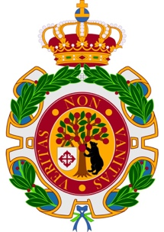

Real Academia Matritense
de Heráldica y Genealogía

Madrid, February 28, 2022

Dear Presidents of the European Faleristic Societies, dear representatives of chancelleries, collectors, museums and related institutions, dear friends,

Fulfilling our promise, I send you the programme of the XV European Conference of Faleristic Societies, which will take place in Madrid from September 16 to 18, 2022, which are subject to any possible changes or modifications that, during the time that lack for its celebration, could happen, during the remaining time for its celebration.

I am also enclosing the pre-registration form for the XV European Conference, a list of 3, 4 and 5-star hotels close to the venue of the gala dinner, indicating in red which of them are closest to the places where we will meet, and a map of the Villa de Madrid

If possible, please send the program and other documents to your members and put it online on your websites, giving it the widest possible publicity.

We hope you appreciate the program created for you and your partners. We are looking forward to welcoming you to Madrid.

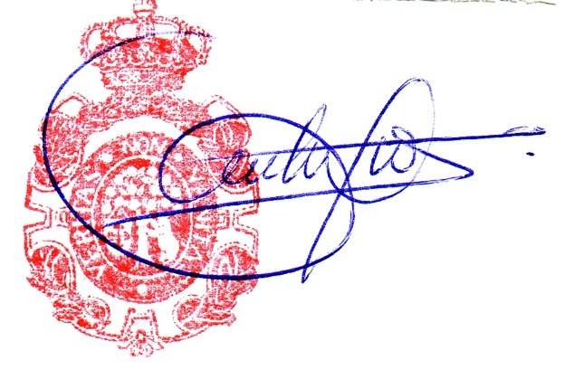
Sincerely yours

Ernesto Fernández-Xesta y Vázquez

Ernesto Fernández-Xesta y Vázquez
Director of the Real Academia Matritense de Heráldica y Genealogía
XV European Conference of Phaleristic Societies
c/ General Arrando, nº 13, bajo izquierda,
28010. MADRID (España)
Tfno.: 34 91 542 81 46
Email: 15conferencephaleristic@gmail.com

